162nd FW FAMILY DAY CAR SHOW
Sunday November 4th, 2018 (0800-1400)

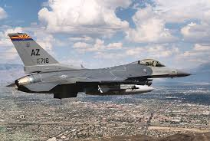
Vehicle Registration Form

NAME: DOB:

Driver’s License Number:

MAKE:

MODEL:

YEAR:

Interesting facts about your vehicle:

POC: SSGT Ron Garcia
Individual Equipment Element (IEE), NCOIC
Email: ronald.s.garcia2.mil@mail.mil
(520) 295-6118

